CIS40A Lab 12: VPN Setup in Windows Server 2022 VM.

In this lab, we will be using Windows Server 2022 VM to setup VPN. Refer to the lab procedures and requirements below.
Windows Server 2022 VM can be located via Google Drive or external USB drive (in classroom).
Link to shared folder containing zipped VM:
https://drive.google.com/file/d/1rrEeJ4ZDONNsppRU8gB8nYbpftKYSrBN/view?usp=sharing
https://drive.google.com/file/d/1rrEeJ4ZDONNsppRU8gB8nYbpftKYSrBN/view?usp=drive_link

DirectAccess
Deploying a single DirectAccess server provides the following:
- Ease of access. Managed client computers running Windows 10, Windows 8.1, Windows 8, and Windows 7 can be configured as DirectAccess client computers. These clients can access internal network resources via DirectAccess any time they are located on the Internet without needing to log in to a VPN connection. Client computers not running one of these operating systems can connect to the internal network via VPN.
- Ease of management. DirectAccess client computers located on the Internet can be remotely managed by Remote Access administrators over DirectAccess, even when the client computers are not located in the internal corporate network. Client computers that do not meet corporate requirements can be remediated automatically by management servers. Both DirectAccess and VPN are managed in the same console and with the same set of wizards. Additionally, one or more DirectAccess servers can be managed from a single Remote Access Management console
- Recommendations:
- Windows Firewall must be enabled on all profiles.
- The DirectAccess server is the network location server.
- You want all wireless computers in the domain where you install the DirectAccess server to be DirectAccess-enabled. When you deploy DirectAccess, it is automatically enabled on all mobile computers in the current domain.
- If VPN is enabled, a DHCP server is required to allocate IP addresses automatically to VPN clients, if a static address pool is not used.
- During remote management of DirectAccess client computers, clients initiate communications with management servers such as domain controllers, System Center Configuration Servers, and Health Registration Authority (HRA) servers for services that include Windows and antivirus updates and Network Access Protection (NAP) client compliance. The required servers should be deployed before beginning the Remote Access deployment.
- If Remote Access requires client NAP compliance, NPS and HRS servers should be deployed before beginning remote access deployment
- The DirectAccess server must be a domain member. The server can be deployed at the edge of the internal network, or behind an edge firewall or other device.
- If the DirectAccess server is located behind an edge firewall or NAT device, the device must be configured to allow traffic to and from the DirectAccess server.
- The person deploying remote access on the server requires local administrator permissions on the server, and domain user permissions. In addition, the administrator requires permissions for the GPOs used in DirectAccess deployment. To take advantage of the features that restricts DirectAccess deployment to mobile computers only, permissions to create a WMI filter on the domain controller are required.
- An Active Directory security group is required to contain the computers that will be configured as DirectAccess clients. If a security group is not specified when configuring DirectAccess client settings, by default the client GPO is applied on all laptop computers in the Domain Computers security group.

Configure VPN
- Open VirtualBox app.
- Locate CIS40AVM folder Windows Server 2022 VM.
- Click on Settings Network and change Bridged Adapter.
- Boot and login Windows Server 2022 VM. Click Input, keyboard, then enter password (password = CIS40A!)
- In Windows Server 2022, search for “PowerShell” and open the application.
- In PowerShell, use the following commands to install Remote Access, DirectAccess-VPN and Routing.
Install-WindowsFeature RemoteAccess
Install-WindowsFeature DirectAccess-VPN -IncludeManagementTools
Install-WindowsFeature Routing -IncludeManagementTools
exit

Creating VPN Group and Users
- In Server Manager, click Add Roles and Features. Use the wizard and select DNS, AD DS and install their features. Configure DNS and promote your domain in AD DS as seen in prior lab, Lab 9. Refer to Lab 9 for instructions on DNS and AD DS installation and configuration.
- click Tools, then select Active Directory Users and Computers.
- On the left pane of AD Users and Computers, click your domain controller and double click Users folder.
- On the right pane, right-click and select New, then Group.
- Enter the group name: Mobile Workers.
- Select Global group and Security options. Click OK.
- Universal Group: It can contain users and groups (global and universal) from any domain in the forest. Universal groups do not care about trust. Universal groups can be a member of domain local groups or other universal groups but NOT global groups.
- Global Group: It can contain users, computers, and groups from same domain but NOT universal groups. It can be a member of global groups of the same domain, domain local groups or universal groups of any domain in the forest or trusted domains.
- Domain Local Group: It can contain users, computers, global groups, and universal groups from any domain in the forest and any trusted domain, and domain local groups from the same domain. It can be a member of any domain local group in the same domain. The difference from domain groups: local groups work even if the domain controllers cannot be contacted.
- Right-click the Users folder, then select New User.
- Create the following users:
- Alex Smith, Logon username: ASmith, password: P@s$word; Must change password at next logon
- Gabriela Flores, Logon username: GFlores, password: P@s$word; Must change password at next logon
- Arthur Chen, Logon username: AChen, password: P@s$word; Must change password at next logon
- Tina Brown, Logon username: TBrown, password: P@s$word; Must change password at next logon
- Right click each user and select Add to a Group.
- Enter “Mobile Workers” and click OK, then click OK to confirm.
Take a screen capture showing the users and group were created for lab submission. 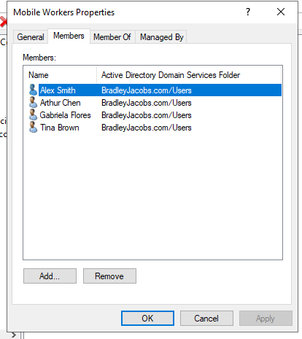
- Close AD Users and Computer management console.

Configure DirectAccess
- Click on Tools Remote Access Management
- On the left pane, click Direct Access and VPN.
- Click Run the Remote Access Setup Wizard.
- Click Deploy both DirectAccess and VPN (recommended).
- In step 1, click Configure button.
- Keep the first option selected, click Next.
- In Select Group, click Add.
- Enter “Mobile Workers” to locate the group, then click OK.
- Click Enable Direct Access checkbox for mobile computers only. Click Next.
- Double-click the Resource field, select Ping and enter SERVERNAME.YOURDOMAIN.com
Note: Enter your server computer name as SERVERNAME and your domain name as YOURDOMAIN.COM
- Click Validate. You should see a green check if your server is connected.
- Click Add button.
- Enter helpdesk e-mail address: helpdesk@YOURDOMAIN.com
The NCA is used to view current connection status and to gather detailed information that is helpful for troubleshooting failed DirectAccess connections.
- Click Finish.
- In Remote Access Setup, click Open RRAS Management on the right.
- Right-click your server on the left pane and select Configure and Enable Routing and Remote Access. Click Next.
- In Configure and Enable Routing and Remote Access Wizard, select Custom Configuration radio button as we will manually configure the routing and access. Click Next button.
- Next, select VPN Access and NAT checkboxes and click next to see a summary of the selection.
- Finally, on clicking Finish button, you will see a prompt to start the Routing and Remote Access Services. Click on the Start Service button.
- In Remote Access Setup, click Open RRAS Management on the right.
- Now that we have our VPN running, we will configure it. Under the Routing and Remote Access window, on the left pane, right-click on your local server and click Properties.
- Navigate to the security tab and click on Allow custom IPSec policy for L2TP/IKEv2 connection and put a very long PSK(Pre-shared key). You can use any tool to generate a random key.
Now, go to IPv4 tab and under IPv4 address assignment select static address pool. Click Add button and you will get a pop up to put IP address ranges. Put the starting address and ending address of the IP address range you want the users to assign to.
Example: 12.0.0.70 – 12.0.0.75
- Click the OK button to save the address range and finally click OK to save the changes. You may get a warning saying you need to restart the Routing and Remote Access for changes to apply, you can safely click OK and ignore it for now as we will restart the service after completing next step.

Configure NAT
- On the same left pane of Routing and Remote Access window, expand your local server and then expand IPv4. You will see the NAT object there. Right-click on NAT and then click on New Interface option.
- Select Ethernet and click OK to proceed further. On NAT tab, select Public interface connected to Internet radio button and also select Enable NAT on this interface checkbox.
- Now, go to Services and Ports tab and select VPN Server(L2TP/IPSec – running on this server) checkbox. It will open up a new interface for editing the service.
- Change the private address from 0.0.0.0 to 127.0.0.1 and click OK to save.
- Finally, Click OK to save the NAT interface.
- This will restart the Routing and Remote Access services and all the changes we have made will be applied.
Take a screen capture of configured NAT for lab submission. 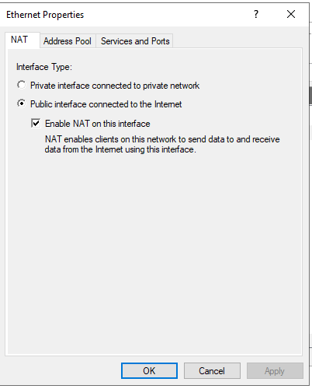

Configure Windows Firewall
- On the start menu, search for Windows defender firewall and open it. Click on Advanced settings on windows defender firewall.
- Under Advanced setting, click on Inbound Rules on the left pane and then click on New Rule on right side pane.
- Windows Server 2022 has predefined rules which we need to enable for VPN to work. In New Inbound Rule Wizard click on Predefined radio button and select the Routing and Remote Access from the drop-down.
- Under Predefined Rules select Routing and Remote Access(L2TP-In) checkbox and click Next.
- Under Action select, the option Allow the connection and click Finish. The firewall is now configured to allow inbound traffic on UDP port 1701.
Take a screen capture of the newly added firewall rule. 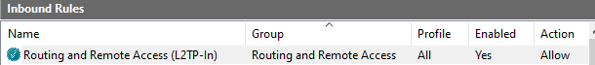
- Close all windows and shut down Windows Server 2022 VM.
- Login Canvas to submit a document that contains lab screen captures.
- Remove USB and shutdown classroom computer.

